
4-th INTERNATIONAL TABLE TENNIS TOURNAMENT
“ROTARY CLUB” MOMCHILGRAD
ORGANISATION: TTSC “RODOPI” MOMCHILGRAD
PATRONAGE: “ROTARY CLUB” MOMCHILGRAD
DATE: 09 - 10 april 2022 /saturday and sunday/
LOCATION: TWON MOMCHILGRAD, region KARDJALI
VENUE: SPORT HALL “RODOPI” MOMCHILGRAD
EQUIPMENT: TIBHAR SMACH 28 R - 8 TABLLES
CATEGORIES: veterans: 40 - 49, 50 - 59, 60 - 69 and 70+
EVENTS: MEN’S SINGLE and MEN’S DOUBLES
PRIZES-single: 1-st place - 50 leva, CUPS, MEDALS, DIPLOMA, SOUVENIRS AND GIFTS
2-nd place - 30 leva, MEDALS, DIPLOMA, SOUVENIRS AND GIFTS
3-rd place - 20 leva, MEDALS, DIPLOMA, SOUVENIRS AND GIFTS /two thirds places/
doubles: medals for first,second and two thrird places
SYSTEM OF PLAY:
ALL INDIVIDUAL EVENTS WILL BE PLAYED IN GROUPS OF 4-5 PLAYERS-Round Robin.
THE BEST TWO PLAYERS FROM EACH GROUP WILL PROGRESS TO THE FINAL.
WILL BE PLAYED ACCORDING TO THE ELIMINATIONS SYSTEM- KO.
THE DOUBLE EVENTS WILL BE ALWAYS UNDER THE KNOCKOUT SYSTEM.
ALL EVENTS WILL BE PLAYED BEST OF 3 GAMES.
ENTRIES: NAME AND SURNAME, DATE OF BRITH, NATIONALITY, AND DOUBLES PARTNER - NAME AND SURNAME, WITH DATE OF BRITH.
ENTRY FEE: 20 EURO /FOR BOTH SINGLE AND DOUBLES/ GALA DINNER: 15 EURO

ACCOMMODATION:
Аpart-hotel „Централ” + 359 88 799 88 99 www.clubmakaza.com
hotel „Берито” + 359 88 888 51 21 www.berito.com
hotel”MG” + 359 88 834 26 41 www.hotelcomplexmg.com
hotel „Конак” + 359 88 712 79 79 www.konak.bg
reservation period directly to hotels: 25 march 2022
ENTRIES MUST BE SENT BY EMAIL TO THE ORGANIZER:
Dimitar Karaivanov mobile: +359 89 87 26 964/Vibar and WhatsApp/ Email: dkara@mail.bg
FINAL ENTRIES: 05 april 2022

PRELIMINARY PROGRAM:
09 april 2022/saturday/: 10,00 OFFICIAL OPENING
10,30 - 12,00 MEN’S SINGLE- groups
14,00 - 18,00 MEN’S SINGLE - eliminations
20,00 GALA DINNER
10 april 2022/sunday/: 10,00 - 13,30 MEN’S DOUBLES/ 40-59 and 60+/
13,30 PRESENTATION CEREMONY

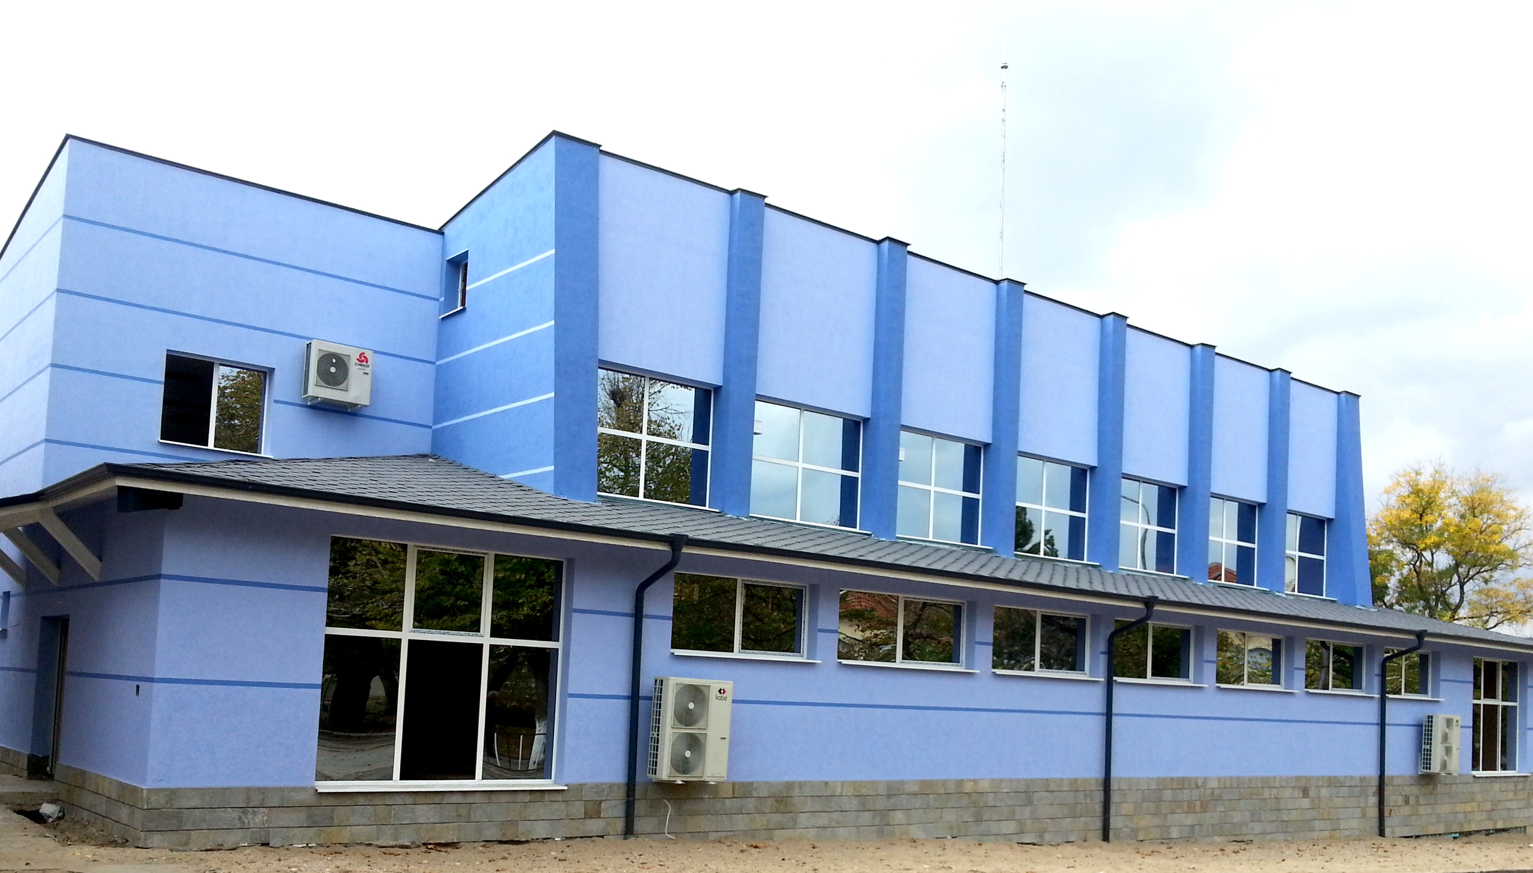

VERY WARM !
WELCOME TO MOMCHILGRAD !

